Cape May Marlin & Tuna Club Trip Fishing Report
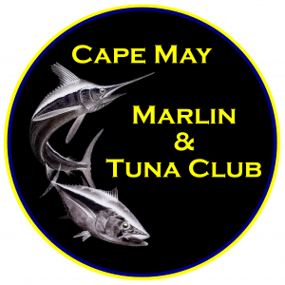
Boat Name:______________________________
Boat Size: 40 ft & Under _______ or over 40ft ________
Trip Date (s) _____________________________
Departure Port __________________________
Return Port ______________________________
- ALL CATCH REPORTS MUST BE UPLOADED TO THE CMMTC REEL TIME APP.
- A COMPLETE FISH REPORT FOR EACH INDIVIDUAL FISH MUST BE SUBMITTED ALONG WITH THE IMAGE OF THIS CATCH REPORT.
- PAPER COPIES OF THE SLIP WILL NO LONGER BE ACCEPTED.
- Special notation column please indicate if Female Angler (Female), Junior Angler (JR include Birthdate must be under 12 years old), Lifetime First of Billfish category.
- Take a Photo or Scan this completed form and upload to CMMTC Reel Time App within 7 days of a catch/release/tag or for tournaments by the published deadline. Upload form with individual fish weighed, released or tagged.
- Any questions email Tournmanets@capemaymarlintunaclub.com
Date | Time | Species | Weight – Lbs  or R (Release) or T (Tagged) | Angler Name | Angler Email | Angler Member Status  (Y or N) | Special Notation

CMMTC Approved Weigh Station Name ______________________________
Weighmaster Signature, Date & Time _________________________________
Owner or Captain Signature _________________________________________
The CMMTC Tournament Committee thanks you for your cooperation in filing these reports with CMMTC through the CMMTC Reel Time App. Tight Lines and Following Seas!!!

